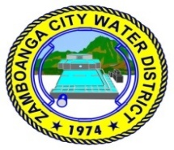
Republic of the Philippines
ZAMBOANGA CITY WATER DISTRICT
Pilar St., Zamboanga City

MINUTES OF THE PRE-BID CONFERENCE UNDER PUBLIC BIDDING FOR PURCHASE REQUISITION NO. 20-0096 – SUPPLY & DELIVERY OF 2,500 BAGS ALUMINUM SULFATE – 17% FOR USE IN WATER TREATMENT HELD VIA VIRTUAL VIDEO CONFERENCING ON JULY 30, 2020 AT 2PM

Present were:

Michael Angelo M. Carbon - Chairperson
Louella A. Aguilera - Vice-Chairperson
Efren C. Salvacion - Regular Member
David Capopez - Regular Member
Tedilito R. Sarmiento - End-user
Jennifer P. Sison - Head, BAC Secretariat
Jeanette B. Delos Santos - Member, BAC Secretariat
Amor E. Constantino - Member, BAC Secretariat

Also present were:

Gary Betic - Chemical Research Products Industrial Sales, Inc.
Jacqui Acollador - Hyper Kem & Machineries Inc.
Melchiades Marigomen, Jr - Jedaric Chemicals Co., Inc.

Absent:
Atty. Vincent Fernandez - Regular Member

Minutes Meeting No. 2020-07-30-20-0096
Series of 2020
Part I. Call to Order

Upon determination of a quorum the meeting was called to order by the BAC Chairperson at 2:00 pm.

Part II. Business Matters

Pre-Bid Conference under Public Bidding for Purchase Requisition Nos. 20-0096 – Supply & Delivery of 2,500 bags Aluminum Sulfate – 17% for use in water treatment with an Approved Budget for the Contract in the amount of Two Million Seven Hundred Thousand Pesos (P 2,700,000.00) and the procurement method is Competitive Bidding.

- Chairperson Carbon called the 27th BAC Meeting to order.

- Letter of Invitation was sent to COA and observers, however none replied.

- It was discussed that Addendum No. 2020-007 was duly posted in Phil-GEPS and ZCWD websites. Also, posted in the conspicuous places in the office of ZCWD.

- Chairperson Carbon introduced the members of Bids and Awards Committee and end-user of the project. Bidder representatives also introduced themselves and the company it represents.

- Chairperson Carbon said, absence in the pre-bid conference will not preclude other bidders to join this particular bidding.

- Chairperson Carbon said, it will go through the Invitation to Bid for PR No 20-0096 and if there are any questions from the bidders, it will be entertained and if it merits the issuance of an Addendum, then it will be issued accordingly.

- Chairperson Carbon inquired from the bidders present if it has read Addendum No. 2020-007, to which all the bidders answered in affirmative.

- Chairperson Caron said, basically the addendum for PR Nos. 20-0096 & 20-0097 are the same. The addendum just states the basis for conducting the pre-bid conference thru Zoom Meeting and it is covered by GPPB Resolution No. 24-2018.

- This is the pre-bid conference for PR No. 20-0096 – Supply & Delivery of 2,500 bags Aluminum Sulfate – 17% for use in water treatment. Approved Budget for the Contract (ABC) is Two Million Seven Hundred Thousand Pesos (P 2,700,000.00.) This is duly covered by purchase requisition and certificate of availability of funds.

- Delivery of Goods is required 100 calendar days upon receipt of Notice to Proceed (NTP) and this is staggered delivery. The staggered delivery schedule is stated in the bid documents.

- The bidding documents had been available since July 22, 2020, it was uploaded in the website of ZCWD and Phil-GEPS and it can be downloaded.

- Bidders should pay the Five Thousand Pesos (P 5,000.00) fee during or even before the deadline for the submission. The submission must be accompanied by the Official Receipt for the payment for said bidding documents.

- The deadline for the submission of the bids as well as the opening will be on August 11, 2020 at 2pm at the BAC. The bids can be submitted at the Office of the BAC, 3rd floor, ZCWD Building Pilar Street, Zamboanga City.

- Chairperson Carbon requested that for those who have questions to kindly, raise hands.

- Chairperson Carbon inquired if bidders have questions for this particular bid, to which all the bidders answered in the negative.

- Chairperson Carbon said, the bidders might not have questions right now but you can still submit your questions thru email or you can write us seven (7) days before the bid opening which is August 4, 2020. For the information of the bidders, we will still accept questions or clarification until August 4, 2020. If your questions are beyond that date then we will no longer take cognizant of those questions.

- Chairperson Carbon inquired from end-user Sarmiento if it has any other information relative to this bidding, to which end-user Sarmiento answered in the negative.

- Chairperson Carbon said to end-user Sarmiento to coordinate with the BAC Secretariat if there is a need to issue an addendum or supplemental bid bulletin for the bidders.

- Mr. Gary Betic, bidder representative from Chemical Research expressed his concern regarding their documents that will be couriered from Manila to Zamboanga which will take around two (2) weeks to be processed by LBC and the bid opening is already on August 11, 2020. Chairperson Carbon said that it understands, however there are other courier services.

- Chairperson Carbon said, as of this moment, the BAC of ZCWD is just in the stages of implementing to receive the electronic submission of bids. It is not yet in placed, as such it was not specifically included in the bidding documents that the bidders can submit electronically.

- The original intent of the end-user is, there is submission of samples, however it was waived. Samples can be accepted and inspected during delivery as stated in the bid documents provision for acceptance and delivery.

- Chairperson Carbon said, the item is needed by the end-user and bidders can explore other courier services.

- As the days progress, in case there is declaration of an Enhanced Community Quarantine (ECQ) which will hamper courier services as well as other freight services, then it will be considered. Since we are in General Community Quarantine (GCQ) where the guidelines are relaxed, we will stick with the August 11 deadline.

- Chairperson Carbon inquired if there are any more questions, to which all the bidders present answered in the negative.

- Chairperson Carbon reiterated that bidders have until August 4, 2020 to submit questions.

- Chairperson Carbon concluded the pre-bid conference for PR No. 20-0096 then proceeded with the pre-bid conference for PR No. 20-0097 – Supply & Delivery of 850 drums Liquid PAC for use in water treatment with same bidders’ present.

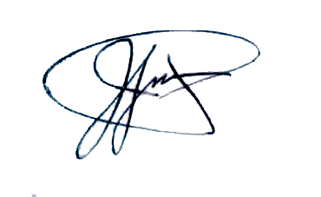
Prepared by: Reviewed by:
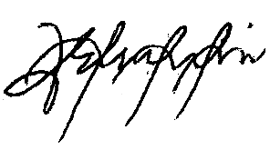

AMOR E. CONSTANTINO JENNIFER P. SISON
BAC Secretariat - Member BAC Secretariat – Head

Noted by:

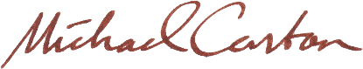

MICHAEL ANGELO M. CARBON
BAC Chairperson

