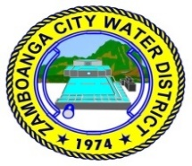
Republic of the Philippines
ZAMBOANGA CITY WATER DISTRICT
Pilar St., Zamboanga City

MINUTES OF THE PRE-BID CONFERENCE UNDER PUBLIC BIDDING FOR PURCHASE REQUISITION NO. 20-0105 – SUPPLY & DELIVERY OF LIQUEFIED CHLORINE GAS FOR USE IN WATER TREATMENT HELD VIA VIRTUAL VIDEO CONFERENCING ON SEPTEMBER 17, 2020 AT 2PM

Present were:

Michael Angelo M. Carbon - Chairperson
Efren C. Salvacion - Regular Member
David Capopez - Regular Member
Tedilito R. Sarmiento - End-user
Jennifer P. Sison - Head, BAC Secretariat
Jeanette B. Delos Santos - Member, BAC Secretariat
Amor E. Constantino - Member, BAC Secretariat

Also present were:

Gary Betic - Chemical Research Products Industrial Sales, Inc.
Mary Ann Aldaba - Jedaric Chemicals Co., Inc.
Melchiades Marigomen, Jr - Jedaric Chemicals Co., Inc.

Absent:
Louella A. Aguilera - Vice-Chairperson
Atty. Vincent Fernandez - Regular Member

Minutes Meeting No. 2020-09-17-20-0105
Series of 2020
Part I. Call to Order

Upon determination of a quorum the meeting was called to order by the BAC Chairperson at 2:00 pm.

Part II. Business Matters

Pre-Bid Conference under Public Bidding for Purchase Requisition No. 20-0105 – Supply & Delivery of Liquefied Chlorine Gas for use in water treatment with an Approved Budget for the Contract in the amount of Two Million Five Hundred Seventy Six Thousand Pesos (P 2,576,000.00) and the procurement method is Competitive Bidding.
- Chairperson Carbon said, we have the pre-bid conference under Public Bidding for PR No. 20-0105 – Supply & Delivery of Liquefied Chlorine Gas for use in water treatment. Approved Budget Cost (ABC) is Two Million Five Hundred Seventy-Six Thousand Pesos (P 2,576,000.00).

- The bidder representatives introduced themselves and the company it represent.

- Chairperson Carbon said, before we proceed to entertain the questions of our bidders, let me just go through the Invitation to Bid. As stated earlier, the ABC was stated. The Delivery Period is Staggered Delivery:

- 1st Delivery: 4 cyls. for 1 ton cylinder
16 cyls. for 68 kg cylinder
30 days upon receipt of NTP, succeeding deliveries shall be the same quantities 30 days after previous deliveries.

- The bid document fee is Five Thousand Pesos (P 5,000.00).

- Chairperson Carbon said, for Single Largest Completed Contract (SLCC) requirement, the contract submitted must be within five (5) years from the date of submission of the bid. The date of submission is September 29, 2020 at 2pm at ZCWD Office. We still don’t accept electronic submission of bids. Submission will be physical through couriers or personally if you have your representative here in Zamboanga City.

- The bidding documents was started to be uploaded starting September 9, 2020. If you still do not have it, just visit the Phil-GEPS, our website, or you can just ask the BAC Secretariat.

- Before or during the submission of bids, the bidder must have paid the bidding document fee of P 5,000.00.

- Chairperson Carbon said, during the last bidding, all those companies present here know about this that there was a question on the Official Receipt (OR) for the bidding documents. It is not a requirement that it should be included in the bidding documents, inside the envelope. You can submit it prior to your submission. It is not a requirement for disqualification if the OR is not in the bidding documents. If we revisit the requirements for the documentary, the OR for the purchased of bidding document is not stated there. During the post-qualification, if the bidder indeed did not pay, it only submitted, then the BAC Secretariat can easily confirm whether the bidder paid or not. But usually, our process/procedure here requires the submission, not inside the envelope but furnishing the BAC Secretariat, through email or physical submission at the Office. I will make it clear, it is not a requirement to be included in the bidding documents in any of the envelopes and it is not a ground for disqualification if it is not there.

- Bid submission will be on September 29, 2020 at 2pm. Late bids will not be accepted.

- Bids over the ABC shall be outrightly rejected.

- The same procedure, you can attend the bid opening there physically at our office if you have any authorized representative or you can join the Zoom meeting.

- It is incumbent upon the bidder to review the Philippine Bidding Documents specifically for this procurement and it is the responsibility of the bidder.

- We would like to acknowledge the presence of end-user, Mr. Tedilito Sarmiento of the Water Quality Division. The floor is now open for questions, for the bidders, just raise your hand if you have any question. Bidders from Jedaric Chemicals, represented by Ms. Aldaba and Mr. Marigomen answered, there is no question. Mr. Betic, bidder representative from Chemical Research also answered in the negative.

- Chairperson Carbon inquired from end-user if it has any information to offer with regard to the bidding of Liquefied Chlorine Gas, to which Mr. Sarmiento answered, our requirements are already okay.

- Chairperson Carbon said, questions will be entertained until closing hours of September 21, 2020, at 5pm. You can email it, and if your query/clarification is meritorious and will require an Addendum, we will issue such and post it in the Phil-GEPS and e-mail to those bidders who are present here.

- There being no questions for PR No. 20-0105, Chairperson Carbon declared the pre-bid conference for the said PR as concluded.

Prepared by: Reviewed by:
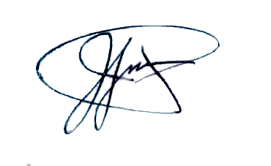
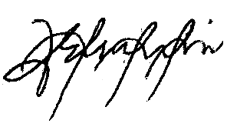

AMOR E. CONSTANTINO JENNIFER P. SISON
BAC Secretariat - Member BAC Secretariat – Head

Noted by:
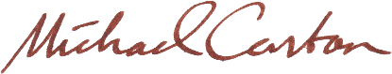

MICHAEL ANGELO M. CARBON
BAC Chairperson

